Chapter 7, Solution 22.

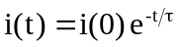, 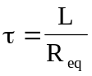
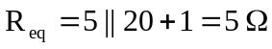, 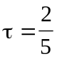

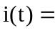 10e^{–2.5t} A

Using current division, the current through the 20 ohm resistor is
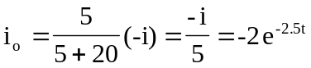

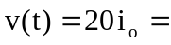 –40e^{–2.5t} V

